Weekly Construction Progress Report – Week 36
Harrow Bay Offshore Wind · 31 Aug – 06 Sep 2026
Elena Márquez · 07 September 2026 · HB-PM-RPT-2026-W36

1. Summary
No monopile was installed this week; the total remains 12 of 40. The foundation campaign is 3 piles behind the Rev 2 baseline (15 planned). Waiting on weather amounted to 58 hours – well above the planning allowance of 25 hours per week.
Area | Status | Comment
Overall schedule | Red | 12/40 monopiles vs. 15 planned
Foundations | Red | TPs installed: 12
Offshore substation | Green | Topside installed 19 Aug
Cables | Red | Export cable 2 delay – HB-RISK-017
HSE | Green | No incidents

2. Progress
Metric | This week | Cumulative | Plan (cum.) | Variance
Monopiles installed | 0 | 12 | 15 | -3
Transition pieces installed | 0 | 12 | – | –
Waiting on weather (h) | 58 | 390 | – | –
Persons on board (avg.) | 100 | – | – | –
Man-hours MV Sea Atlas | 8,639 | 179,276 | – | –
Lost time injuries | 0 | 0 | 0 | 0
Recordable injuries | 0 | 1 | – | –
Near misses reported | 0 | 4 | – | –
HSE observation cards | 15 | – | – | –

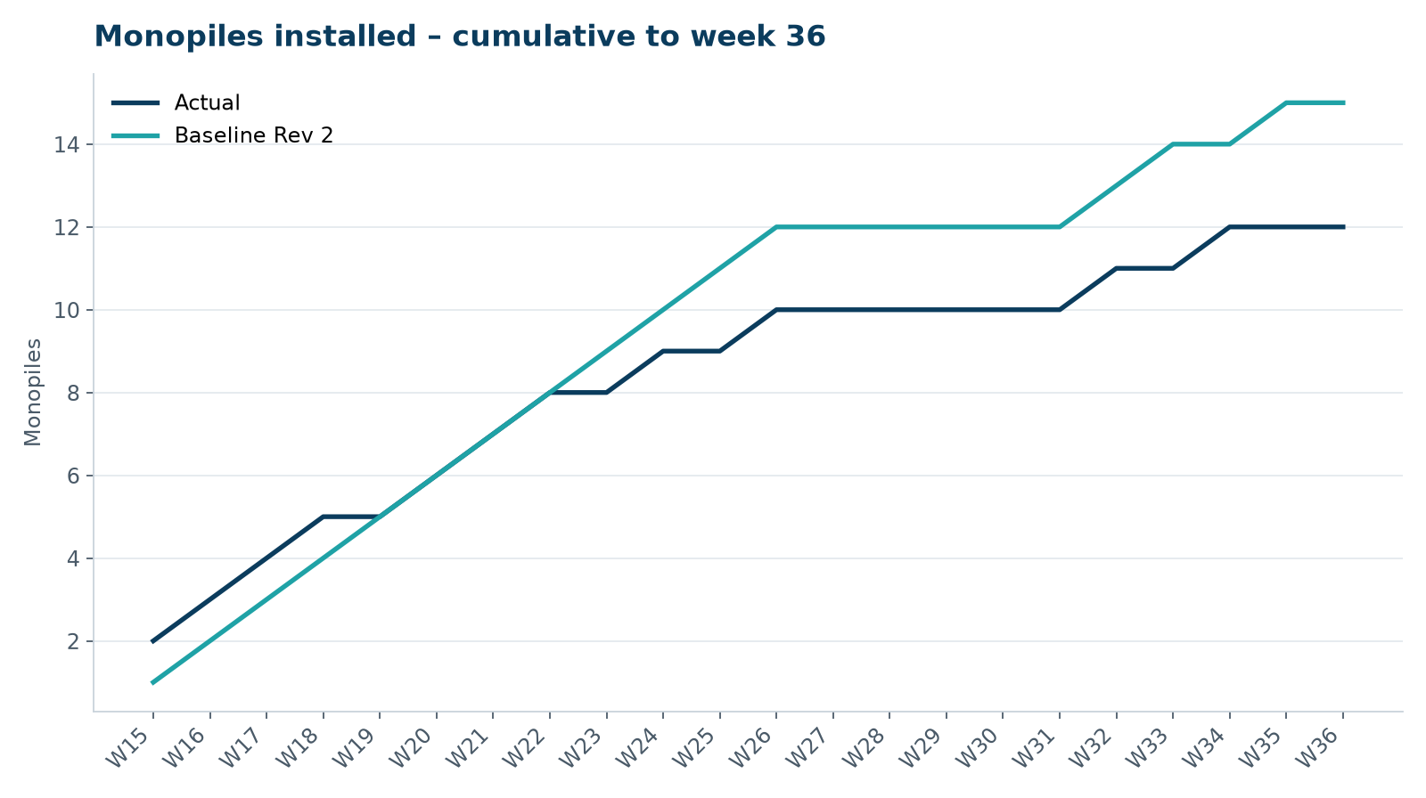
Figure 1 – Monopile installation progress, W15 to W36

3. Key activities this week
- 58 hours waiting on weather (first autumn storm, gusts up to 48 kn on 2 September).
- Cable delay meeting with Severn Subsea Cables on 3 September: recovery programme accepted in principle, liquidated damages reserved.
- No monopile installed.

4. Health and safety
No lost time injuries. 15 observation cards submitted; top theme: housekeeping on the main deck.

5. Environment
- No piling this week; passive acoustic monitoring stations HB-PAM-01 to -04 operational.

6. Issues and risks
- HB-RISK-017 export cable 2 delay – recovery programme received; resequencing of cable lay campaign in progress.
- HB-RISK-001 weather: 58 h downtime this week.
- HB-RISK-029 monopile campaign into winter – recovery plan in preparation.

7. Look-ahead next week
Install HB-A13; cable resequencing study.
Prepared by Project Controls (Gareth Lewis); approved by Elena Márquez. Distribution: project team, Steering Committee, Halden Turbine Systems, Lenders' Technical Adviser.

